1. Explain the important information you can get from following Logs
a. Traffic
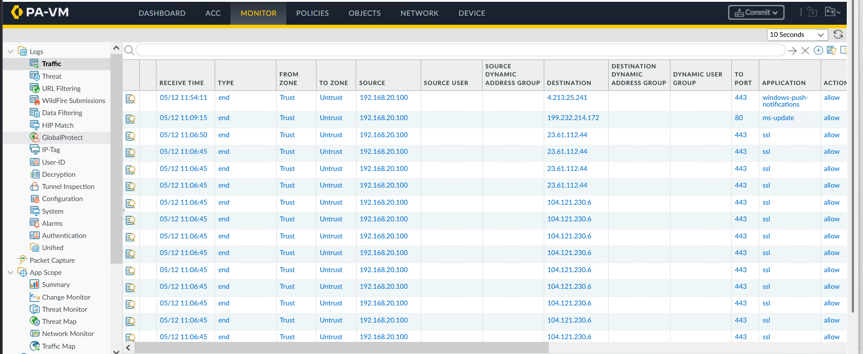
In the traffic log the firewall captures all the header related information in addition to firewall specific information like applications (example ssl, instagram, amazon etc..), source user (with the help of directory services) etc..
b. Threat
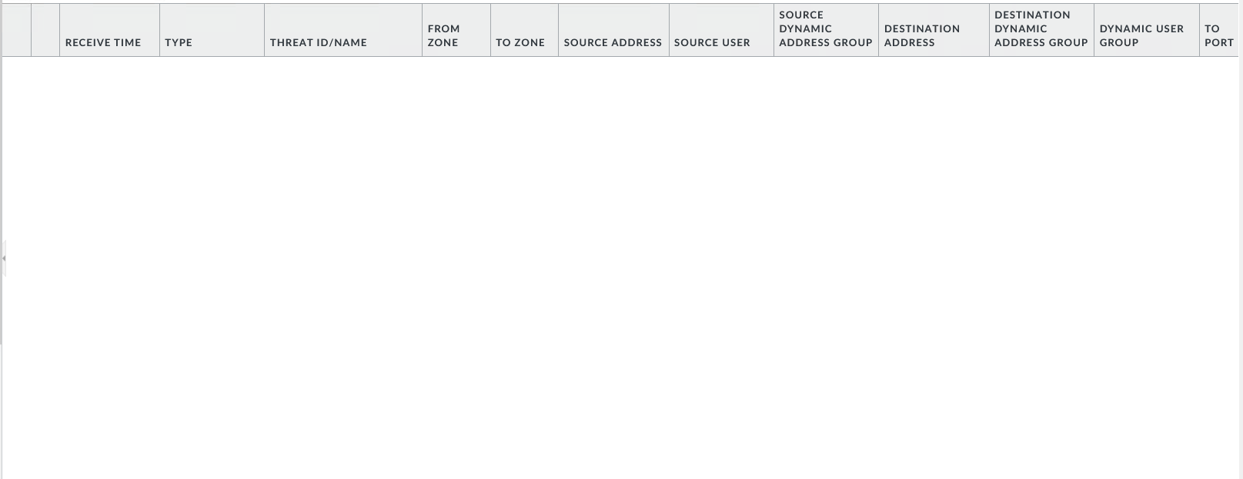
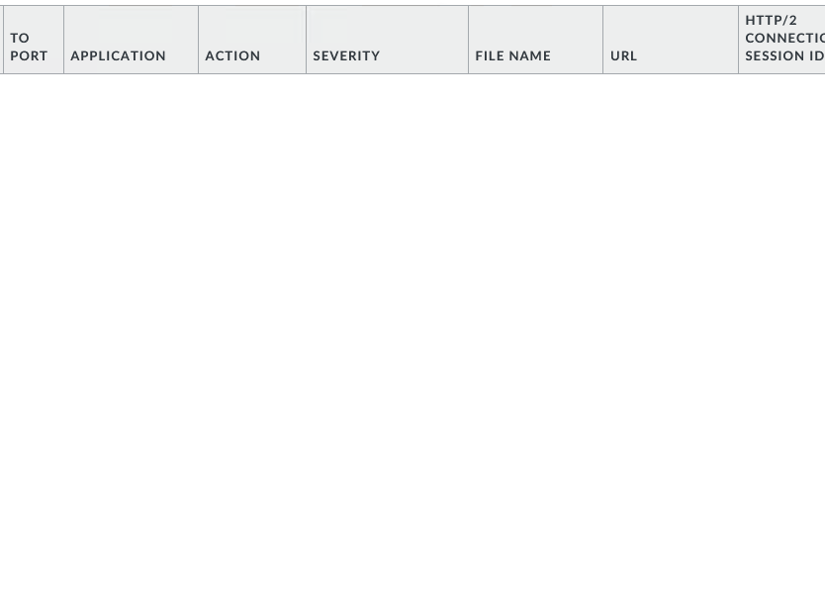
In the threat log the firewall captures threat related information like threat ID, timestamp, source and severity using vendor provided information, in this case palo alto
c. System
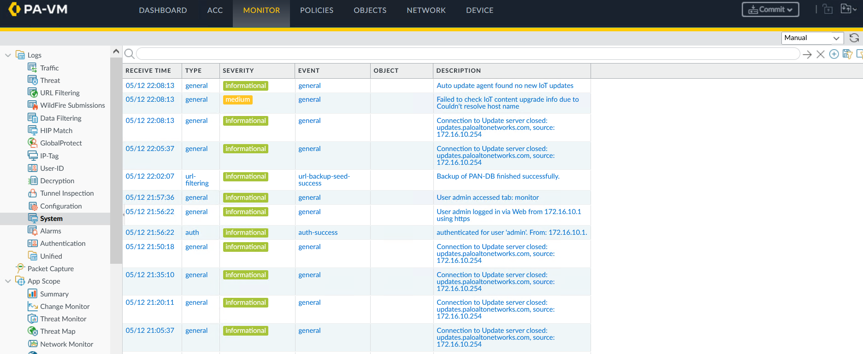
The system logs record information related to system events like updates and operational notifications (like auth-success, url-backup-seed-success in the above screenshot), these system events are different from configurational changes and are related to the operation and maintenance of the firewall.

d. Configuration
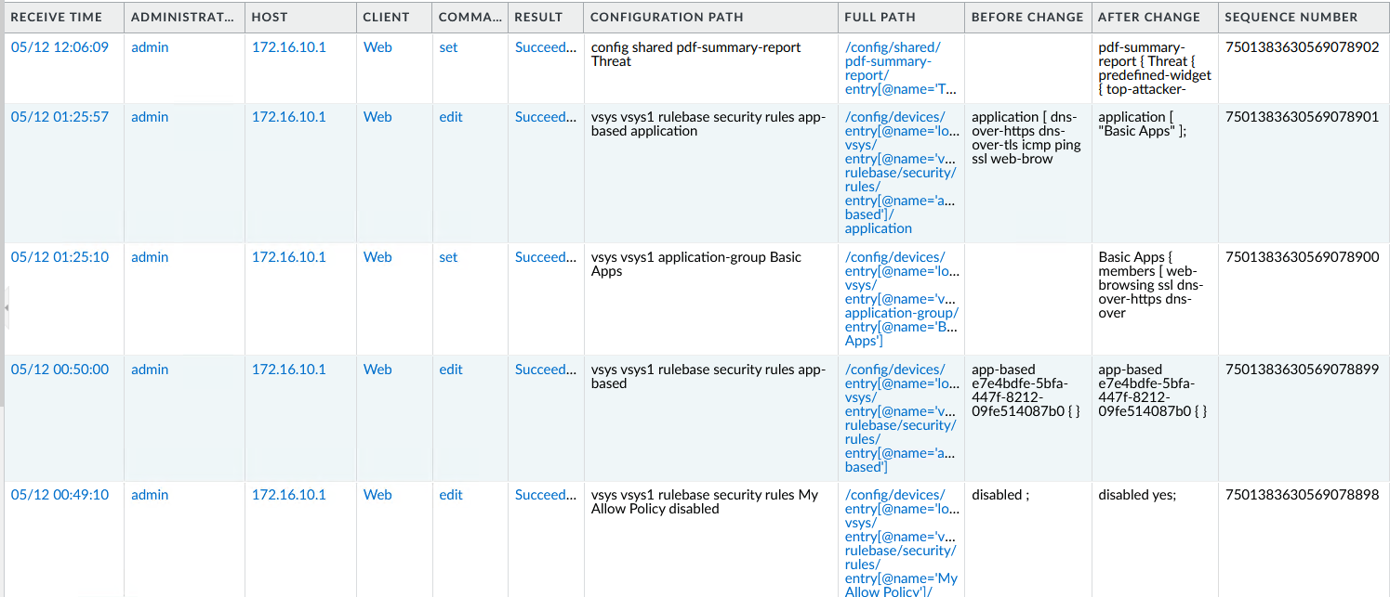

In the configuration log the firewall tracks changes made to the firewall's configuration, the logs capture details regarding configuration changes like who made the changes, the method by which the changes are committed (example GUI, CLI), whether the commit was successful.

